Name – Davender Singh

Student ID – \*\*\*\*\*\*\*\*\*\*

Course – CCP555NSA

Professor – David Humphrey

* Screenshot of running EC2 instance details in the AWS Console

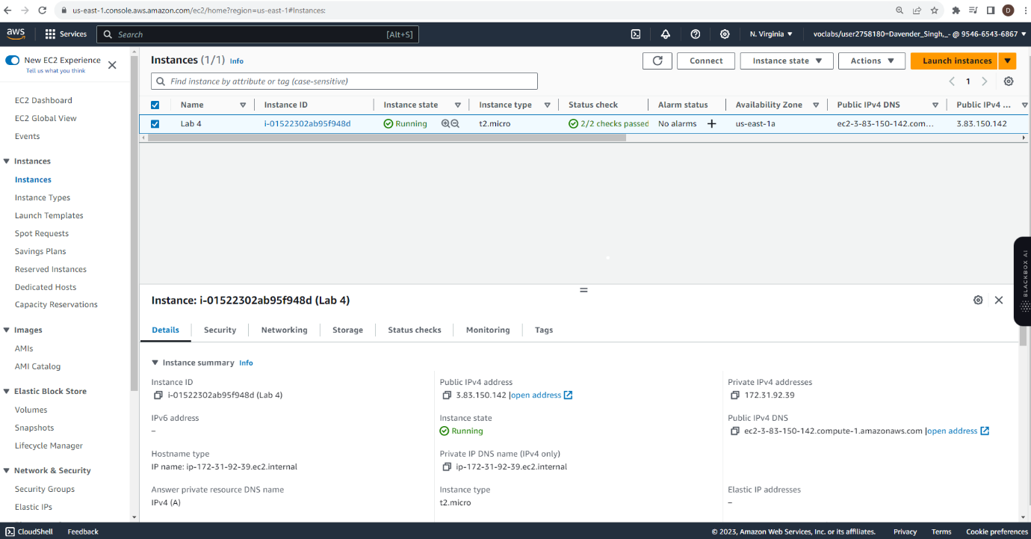

* Screenshot of accessing microservice's health check running on EC2 via the browser

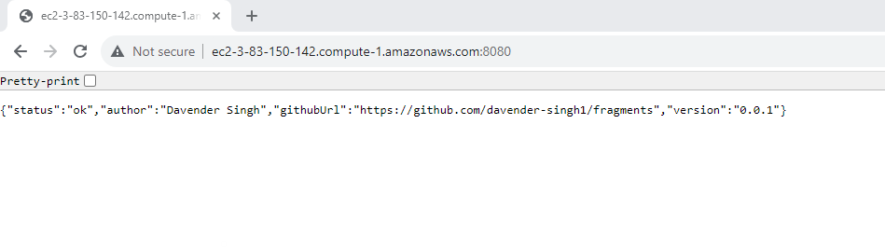

* Screenshot of accessing microservice's health check running on EC2 via curl in a terminal on your local computer

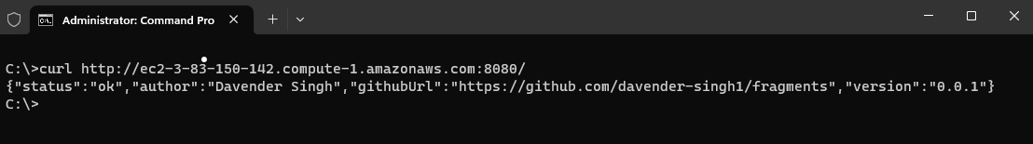

* Screenshot of accessing microservice's health check running on EC2 via curl in a terminal on the EC2 instance accessed via localhost

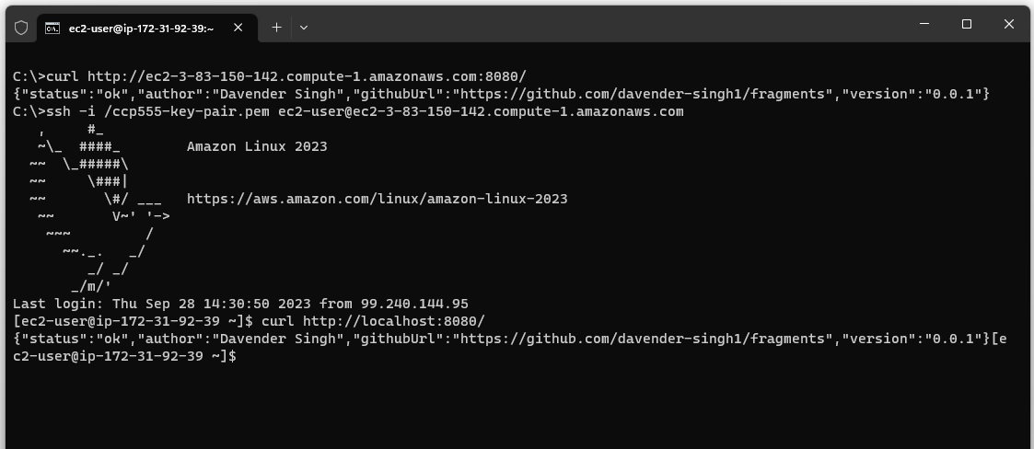

* Screenshot of starting your EC2 instance in the AWS CLI with output

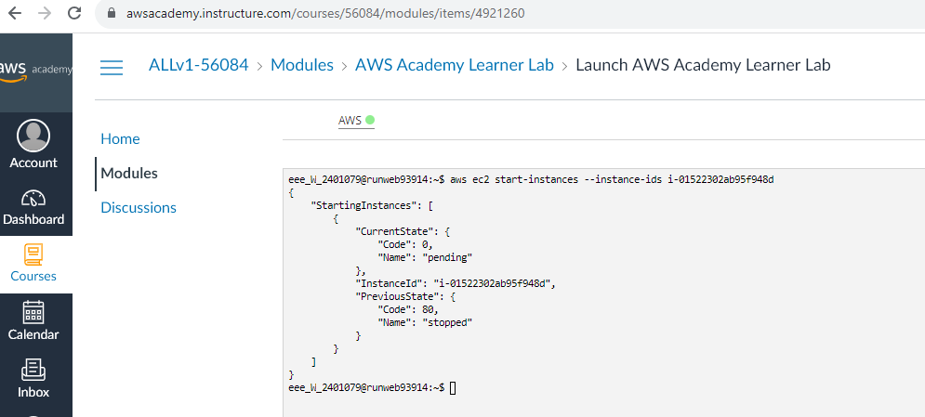

* Screenshot of stopping your EC2 instance in the AWS CLI with output

